ATM SIMULATOR

Software Requirement Specification
(SRS)

Version 1

April 2025

Proposed By:
Aetesam Asfar Ullah – 092
Anas Niaz – 106
Anas Umar Khan – 051

Table of Contents
1 Introduction 3
1.1 Purpose 3
1.2 Document Conventions 3
1.3 Project Scope 3
1.4 Reference 3
2 System Description 3
3 Functional Requirements 3
3.1 System Features 3
3.1.1 User Authentication 3
3.1.2 Transaction Handling 3
3.1.3 Mini-Statement Generation 4
3.1.4 Error Handling 4
3.2 Use Case 4
3.2.1 Use Case Diagram 4
4 External Interface Requirements 5
5 Technical Requirements (Non-Functional) 5
5.1 Performance 5
5.2 Scalability 5
5.3 Security 5
5.4 Maintainability 5
5.5 Usability 5
5.6 Multi Lingual Support 5
5.7 Auditing and Logging 6
5.8 Availability 6
6 Open Issues 6

ATM Simulator

1 Introduction

Purpose
The purpose of this document is to define the functional and non-functional requirements for the ATM Simulator developed using Java Swing in NetBeans. The system allows users to log in, register, make deposits, cash out, and print mini-statements.

Document Conventions

Project Scope
The ATM Simulator is designed to simulate basic banking functionalities, including user authentication, transaction management, and account management. The system will provide a secure and user-friendly interface for handling financial transactions.

Reference

System Description
The ATM Simulator allows users to securely manage their financial transactions. The system is designed to provide basic ATM functionalities, ensuring security, usability, and performance.

Functional Requirements

System Features

User Authentication
- Login
- Registration
- Logout

Transaction Handling
- Deposit
- Cash Withdrawal
- Balance Inquiry

Mini-Statement Generation

Error Handling
- Invalid Login
- Insufficient funds

Use Case

Use Case Diagram
The following use case diagram represents the interactions between users and the ATM Simulator system. It illustrates the key functionalities, including login, transactions, and handling incorrect PIN entries.
Use Case Diagram: Simple ATM Machine System
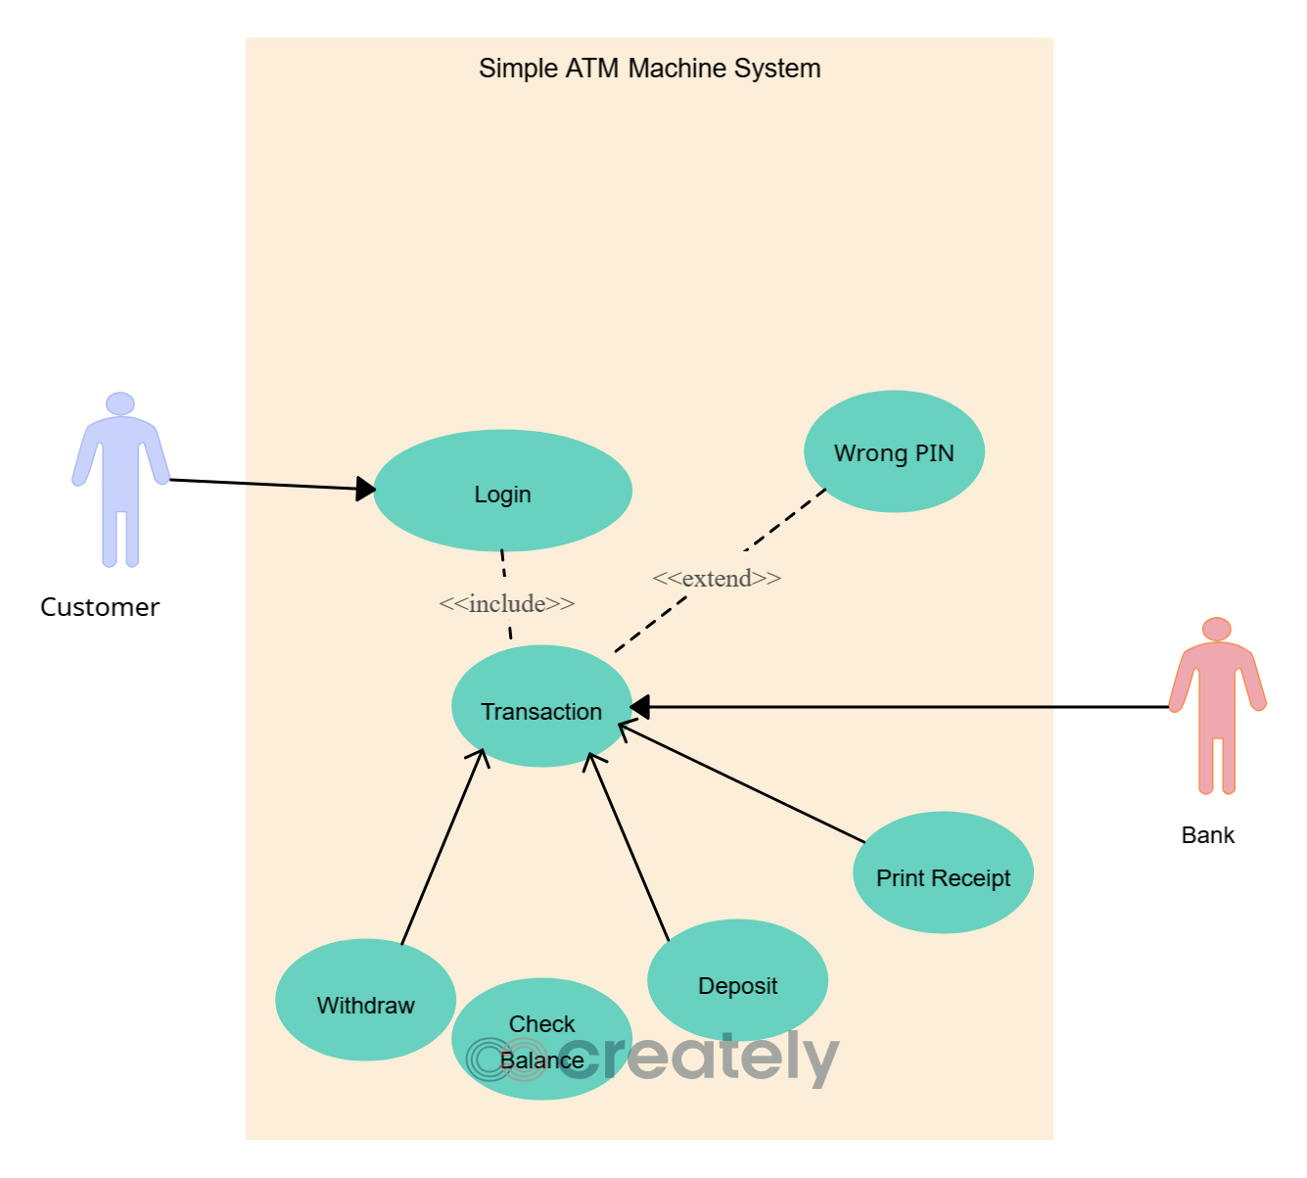

External Interface Requirements
- User Interface: Java Swing GUI
- Database: Java File Handling for storing user and transaction dat

Technical Requirements (Non-Functional)

Performance
- Fast transaction processing with a response time of under 2 seconds.

Scalability
- The system should handle up to 100 simultaneous users.

Security
- Secure database connections.
- Role-based access control.

Maintainability
- Easy code modification.
- Modular design for enhancements.

Usability
- User-friendly UI with clear navigation.
- Accessible interface for all users.

Multi Lingual Support
Future enhancements may include multi-language options

Auditing and Logging
The ATM Simulator system will implement auditing and logging mechanisms to ensure security, detect fraudulent activities, and maintain system integrity. The system will log critical user and system activities for monitoring and troubleshooting purposes.
1. Auditing
- The system will maintain a secure audit trail of user activities, including:
  - Login attempts
  - Transaction details
  - Changes in user account details
  - Failed authentication attempts
- Audit logs will be stored securely and accessible only by authorized personnel for review and analysis.
2. Logging
- The system will log key events for debugging and monitoring, including:
  - System errors and exceptions
  - Transaction failures
  - Database connection issues
  - System shutdowns and restarts
- Logs will be stored in a structured format (e.g., log files, database logs) for easy retrieval and analysis.

Availability
- The system should remain operational during development, testing, and final submission.
- Any known issues affecting availability will be documented and addressed during testing.

Open Issues
- Potential future integrations with online banking services.
- Further enhancements in UI design and accessibility.
- Security concerns such as potential vulnerabilities in user authentication and transaction handling.

